Page 1: https://whywhycoffee.com/en
Example photo
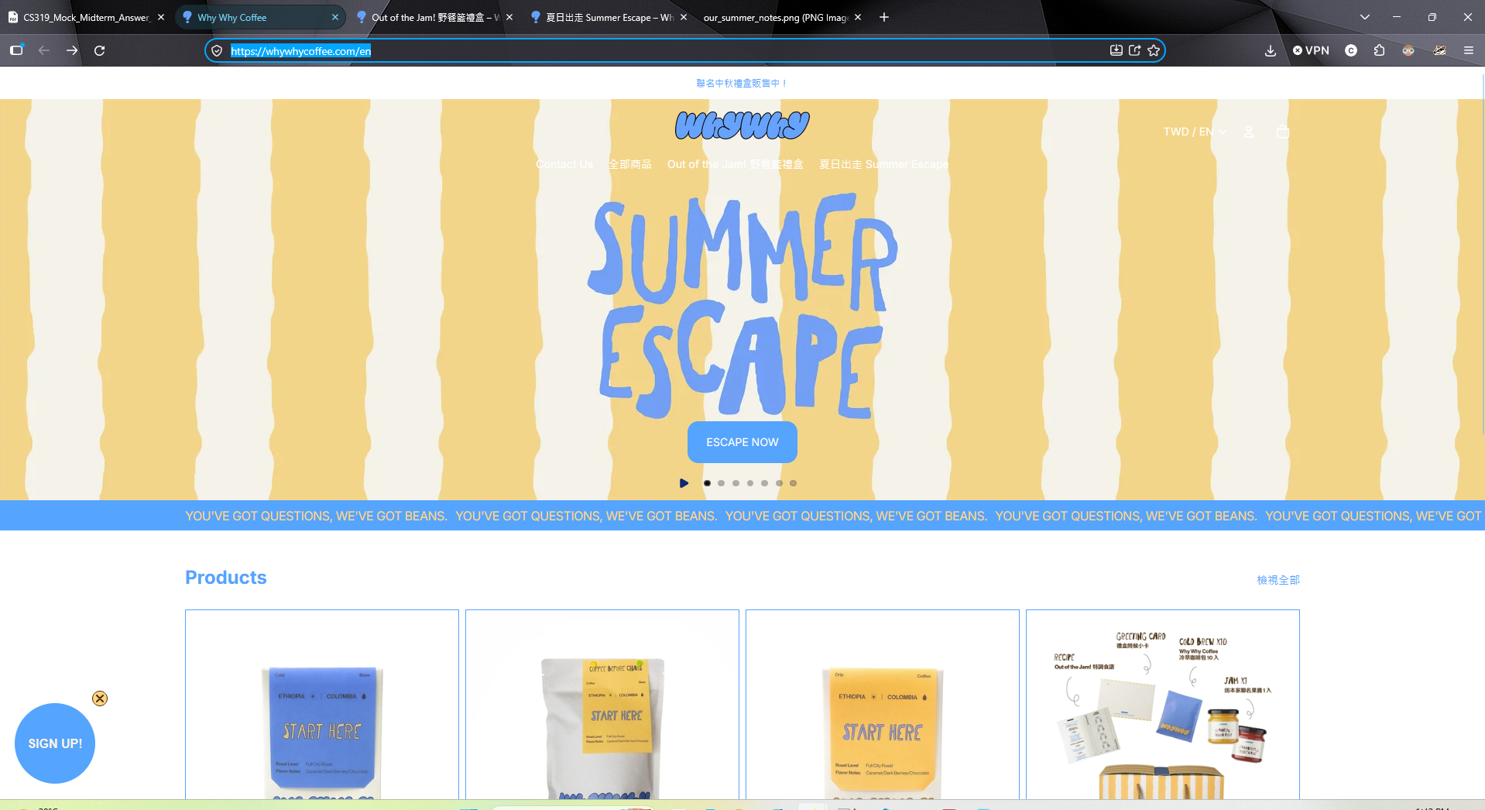

Page 2: https://whywhycoffee.com/en/products/out-of-the-jam-%E9%87%8E%E9%A4%90%E7%B1%83%E7%A6%AE%E7%9B%92
Example photo:
